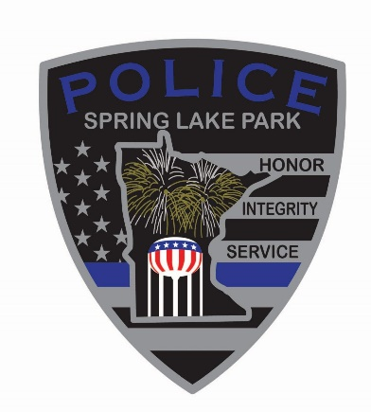

Job Announcement: Full-Time Police Officer

November 4, 2025
Spring Lake Park Police Department

The Spring Lake Park Police Department is accepting applications for a Full-Time Police Officer. Located between Fridley and Blaine, Spring Lake Park is a community of 7,400 residents known for its small-town charm and strong support for public safety.

The department currently includes 12 sworn officers and two support staff. The current process is for the addition of one police officer to the department in early 2026.

Why Join Us?
- New Facility (Opened 2025) with 24/7 access to an on-site gun range
- Career Development:
  - School Resource Officer
  - Rotating Investigator & Traffic Safety Officer
  - Field Training Officer
  - Mobile Field Force & Bike Patrol
  - Instructor roles (Taser, PepperBall, Use of Force, Firearms)
- Wellness Support:
  - Mental health services
  - On-site fitness facility

Qualifications
- Must meet Minnesota POST Board standards
- Must possess or be eligible for a full-time Peace Officer License by appointment

Compensation
2026: $39.47–$53.01/hour ($82,092.60–$110,270.04 annually)
2027: $41.05–$55.14/hour ($85,376.28–$114,680.88 annually)
Lateral transfers encouraged and considered individually

How to Apply
Applications available:
In person at 1301 81st Ave NE, Spring Lake Park, MN (Mon–Fri, 8 AM–4:30 PM)
Online: Job Openings | Spring Lake Park Minnesota
Police Department | Spring Lake Park Minnesota

Deadline: Open until filled

